**Supply Chain Risk Management - Manufacturing Sector**

GOKULNATH K & E24755

**Overview**

Supply Chain Risk Management (SCRM) is the process of identifying, assessing, and mitigating risks within the supply chain to ensure the smooth and efficient flow of goods, services, and information from suppliers to customers. It involves evaluating potential disruptions that could impact supply chain operations, such as natural disasters, geopolitical instability, supplier bankruptcy, cyber-attacks, and market fluctuations. Effective SCRM requires a proactive approach, incorporating risk assessment, contingency planning, and the development of resilient supply chain strategies. This includes diversifying suppliers, maintaining safety stock, implementing technology for real-time monitoring, and fostering strong relationships with key stakeholders. By managing these risks, organizations can enhance their ability to adapt to unforeseen challenges, minimize disruptions, and maintain a competitive advantage in the marketplace.

**Objective**

1. **Identifying and Quantifying Risks:** Utilize data analytics to identify potential risks across the supply chain, such as supplier reliability, transportation delays, or market volatility. This involves collecting and analyzing historical and real-time data to quantify the likelihood and impact of these risks.
2. **Enhancing Supply Chain Visibility:** Implement data-driven tools to gain real-time insights into supply chain operations. This includes monitoring inventory levels, lead times, and supplier performance, enabling early detection of disruptions and inefficiencies.
3. **Optimizing Risk Mitigation Strategies:** Use data analysis to develop and evaluate various risk mitigation strategies, such as diversifying suppliers, optimizing inventory levels, or adjusting production schedules. The goal is to minimize the impact of disruptions while maintaining cost-effectiveness.
4. **Predictive Analytics for Risk Forecasting:** Leverage predictive analytics to anticipate potential disruptions based on trends and patterns in the data. This allows for proactive measures to be taken, reducing the likelihood of supply chain disruptions.
5. **Improving Decision-Making:** Provide actionable insights to decision-makers through data-driven reports and dashboards. This helps in making informed decisions regarding supplier selection, risk mitigation investments, and contingency planning.
6. **Ensuring Compliance and Sustainability:** Use data analysis to ensure that supply chain practices comply with regulations and sustainability goals. This includes monitoring for compliance with environmental standards, labor laws, and ethical sourcing practices.
7. **Building Supply Chain Resilience:** Develop data-informed strategies to enhance the overall resilience of the supply chain. This includes identifying critical nodes in the supply chain, assessing their vulnerabilities, and implementing measures to reduce the impact of potential disruptions.
8. **Continuous Improvement:** Use data analytics to continuously monitor, evaluate, and improve supply chain risk management processes. This involves learning from past disruptions, refining risk models, and updating mitigation strategies to adapt to changing conditions.

**Assigned Task(s)**

* Supply Chain Risk Management - Manufacturing Sector

**Task Details**

* **Task 18:** Supply chain risk management (SCRM) is the process of finding and addressing potential vulnerabilities in a company’s supply chain. SCRM aims to minimize the impact of these risks on a company's operations, reputation and financial performance.
* **Status:** Completed
* **Details:** In the analysis of supply chain risk management for the manufacturing sector, a dataset was created with features such as Supplier ID, Product ID, Lead Time (in days), On-Time Delivery Rate, Demand Forecast, Inventory Level, Transportation Cost, Supplier Risk Score, Order Quantity, Order Date, and Delivery Date. The analysis started by calculating key metrics like the average lead time across all suppliers, the overall on-time delivery rate, and the total transportation cost. These metrics provided a foundation for understanding the performance and risks associated with each supplier.
* To gain deeper insights, several visualizations were created. A bar chart depicting Lead Time by Supplier helped identify suppliers who were taking longer to deliver products, potentially leading to production delays. Another bar chart showed the On-Time Delivery Rate by Supplier, which highlighted the reliability of each supplier in meeting scheduled delivery dates. Lastly, a Supplier Risk Score visualization was generated to assess the risk levels for each supplier on a scale of 1 (low risk) to 5 (high risk). This helped in identifying suppliers who might pose greater risks to the supply chain.
* These analyses and visualizations provided a clear understanding of the supply chain's performance and enabled the identification of high-risk areas. The insights from the analysis could be used to mitigate risks, optimize supplier selection, and improve overall supply chain efficiency.

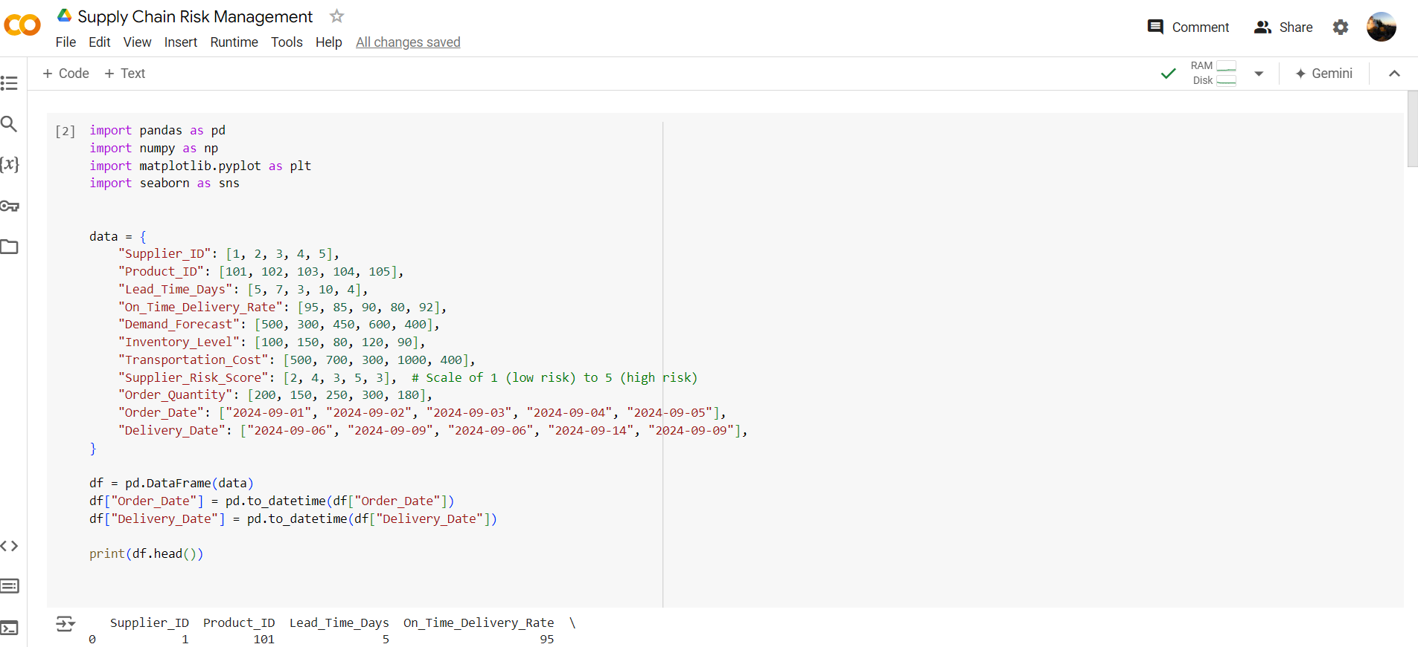

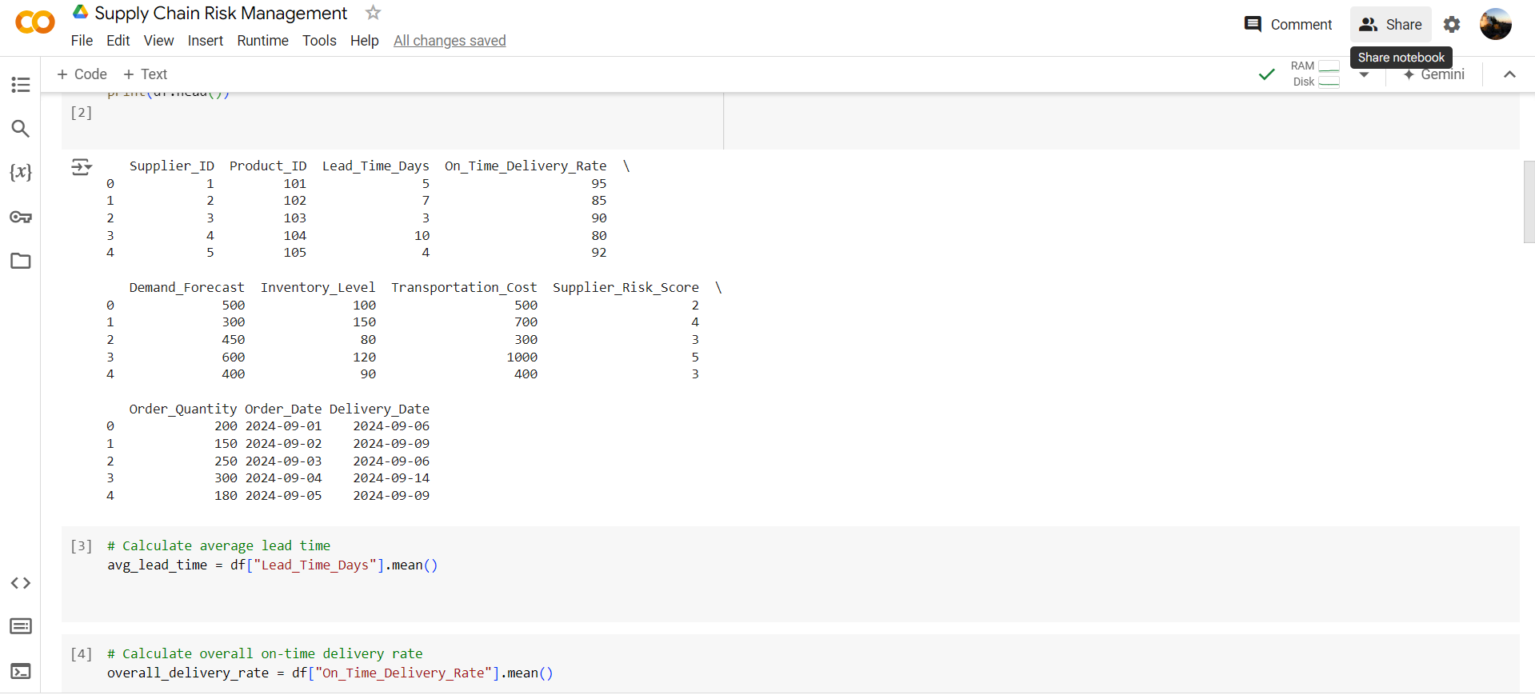

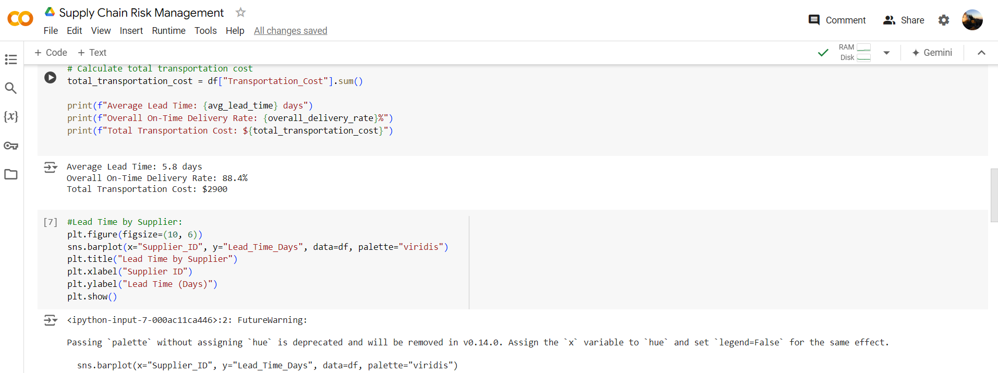

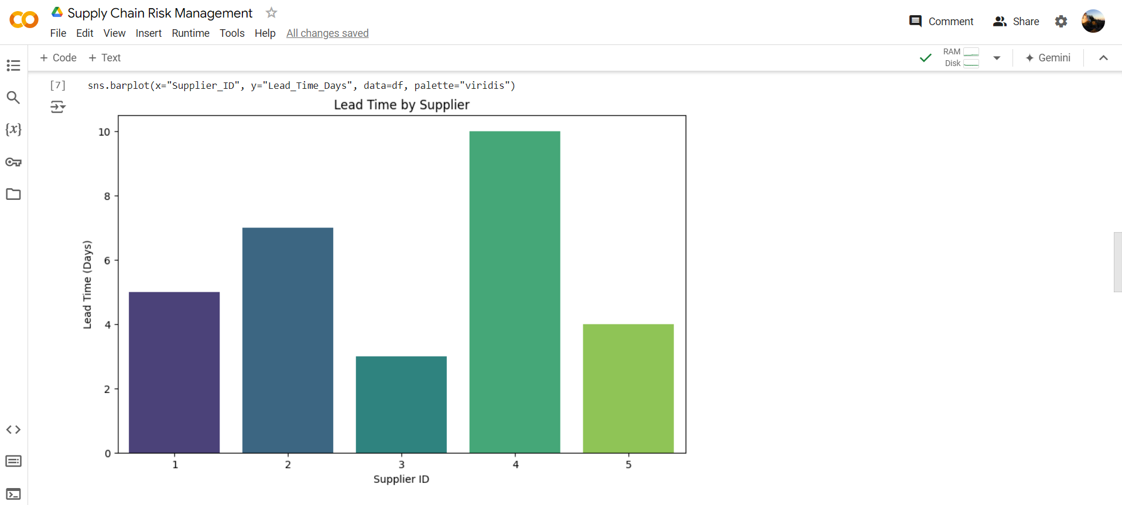

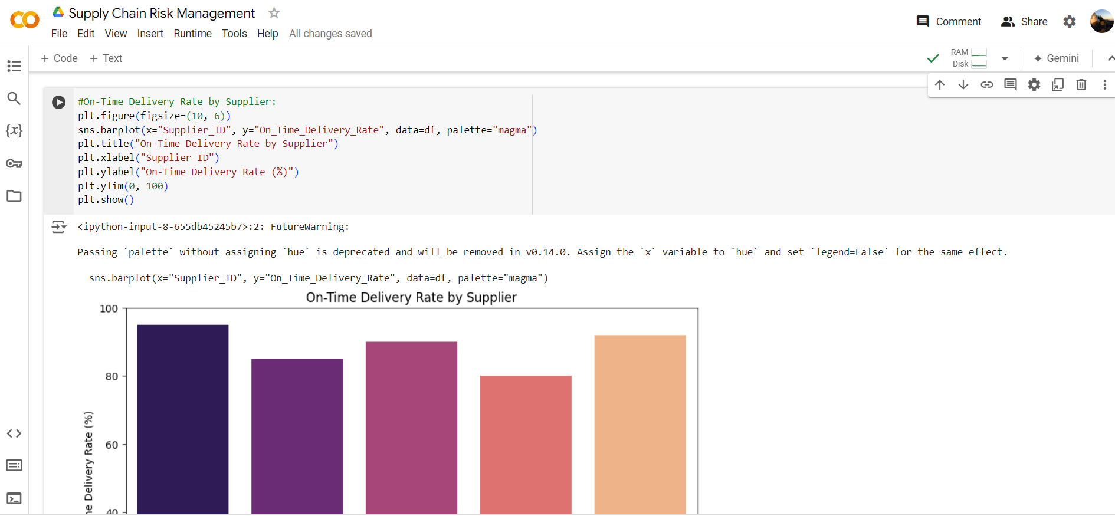

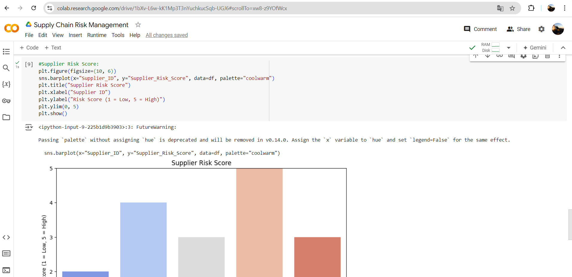

**Progress**

* **Accomplishments:** To accomplish supply chain risk management in the manufacturing sector, I analyzed supplier performance metrics such as lead time, on-time delivery rates, and transportation costs. Risk scores were calculated for each supplier to identify potential risks in the supply chain. Visualizations helped pinpoint suppliers with delays and higher risks. These insights enabled targeted risk mitigation and improved supply chain efficiency.
* **Metrics:** In supply chain risk management, key metrics include Lead Time (average days for delivery), On-Time Delivery Rate (percentage of timely deliveries), Transportation Cost (total cost incurred for shipping), and Supplier Risk Score (1 to 5 scale indicating risk level). These metrics help assess supplier performance, identify potential bottlenecks, and evaluate overall supply chain risks in the manufacturing process.

**Challenges and Solutions**

* **Challenges Faced:**

1. Data quality and inconsistency across multiple sources.
2. Supplier disruptions due to geopolitical, financial, or natural events.
3. Limited visibility and transparency across the entire supply chain.
4. Demand variability and inaccurate forecasting.
5. Complex global logistics and transportation delays.

* **Solutions Implemented:**

1. Implementing data integration tools to improve data accuracy and consistency.
2. Using predictive analytics to anticipate supplier disruptions.
3. Enhancing supply chain visibility with real-time tracking and monitoring systems.
4. Optimizing demand forecasting through advanced AI and machine learning models.
5. Diversifying suppliers to mitigate risks from geographic or logistical challenges

**Next Steps**

* **Upcoming Tasks:** To effectively face upcoming tasks in the manufacturing sector, prioritize planning and resource allocation, use data-driven insights to anticipate challenges, and maintain clear communication and flexibility to adapt to changes.
* **Goals:** To set clear goals for upcoming tasks in the manufacturing sector, start by defining specific, measurable objectives that align with overall business targets

**Conclusion**

* **Summary:** In conclusion, effective supply chain risk management requires addressing data inconsistencies, improving supplier visibility, and using advanced analytics for forecasting and disruption prediction. By implementing real-time monitoring and diversifying suppliers, companies can enhance resilience and minimize risks. These strategies ultimately lead to a more efficient and reliable supply chain in the manufacturing sector.
* **Acknowledgments:** Thank you all for your time and attention. Your engagement and interest in Supply Chain Risk Management in the manufacturing sector are greatly appreciated. If you have any questions or need further information, please feel free to reach out. Have a great day.